**Project 3**

**How to connect private server to internet using NAT gateway (Jump server/bastion host).**

**Virtual private cloud**

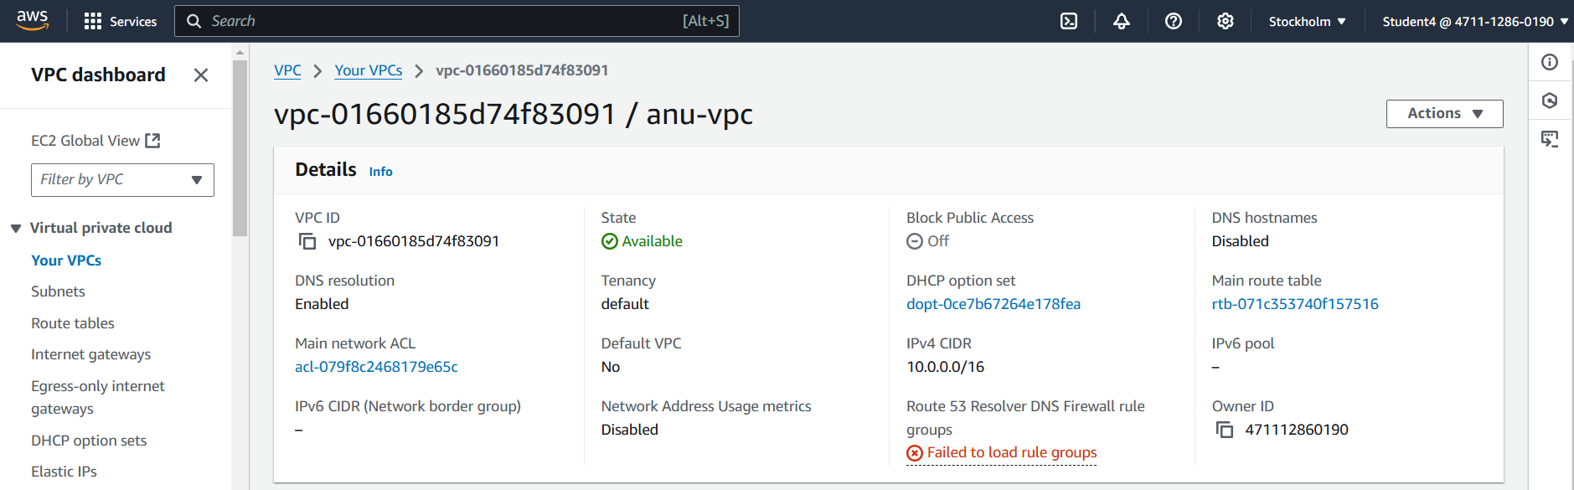

**Internet Gateway:**

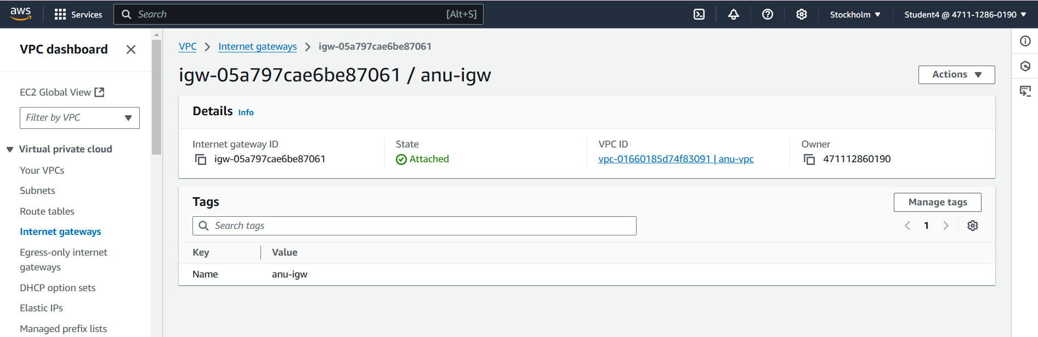

**Public subnet 1:**

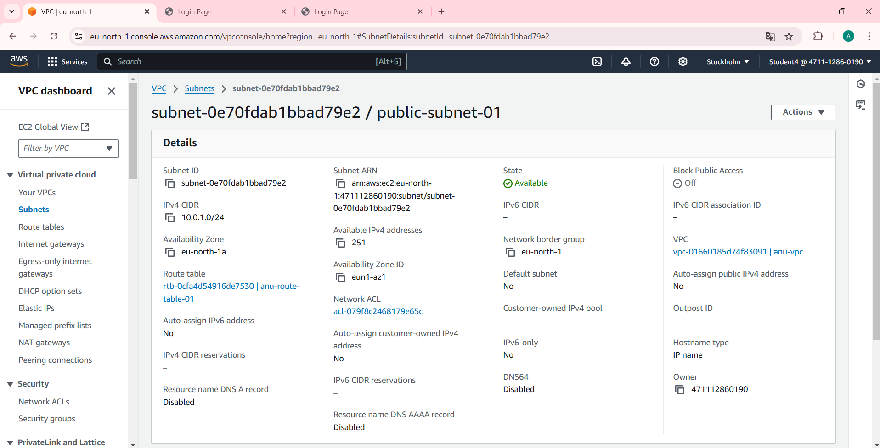

**Public subnet 2:**

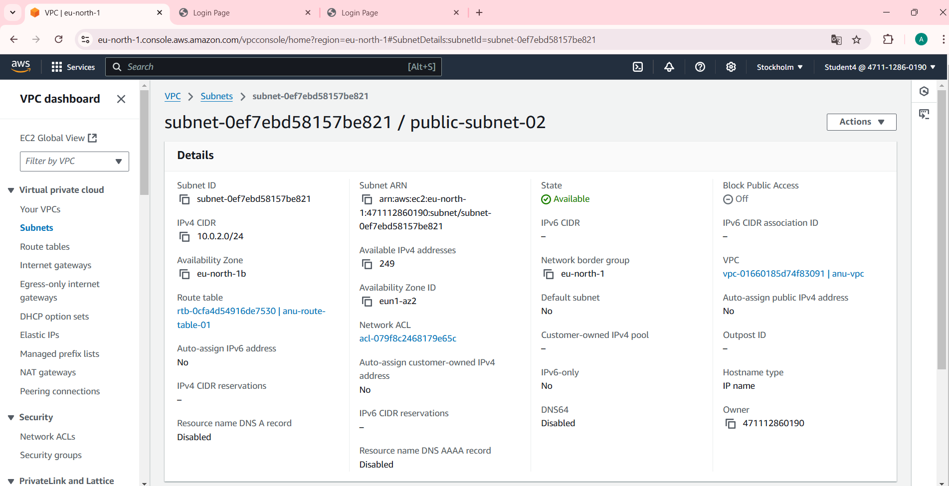

**Public route table:**

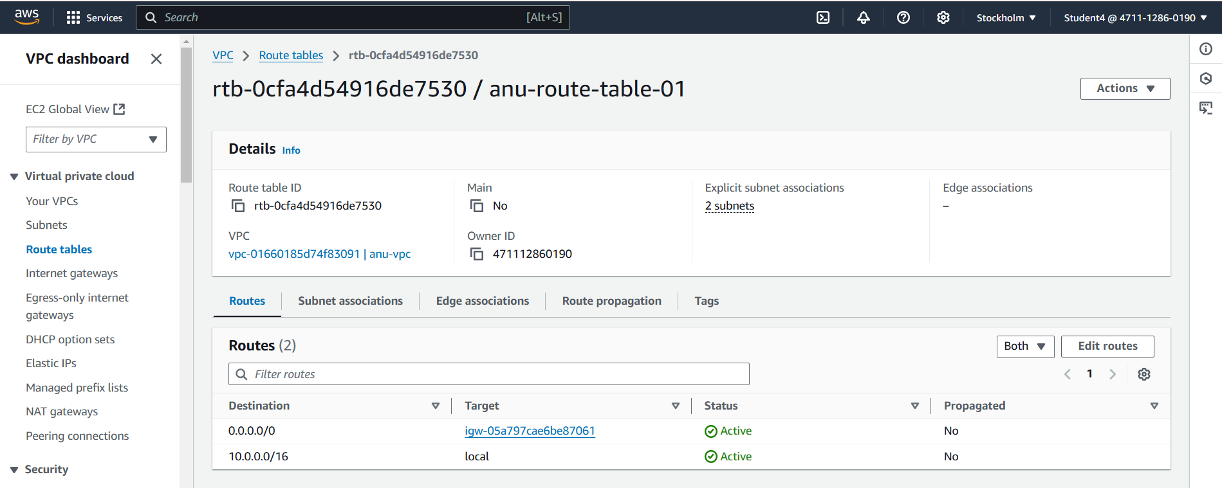

**Private subnet 1:**

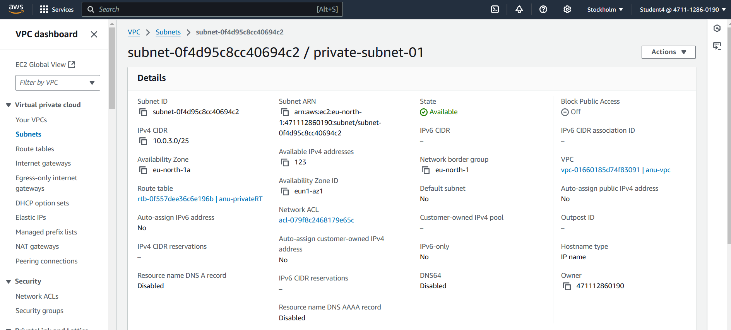

**Private subnet 2:**

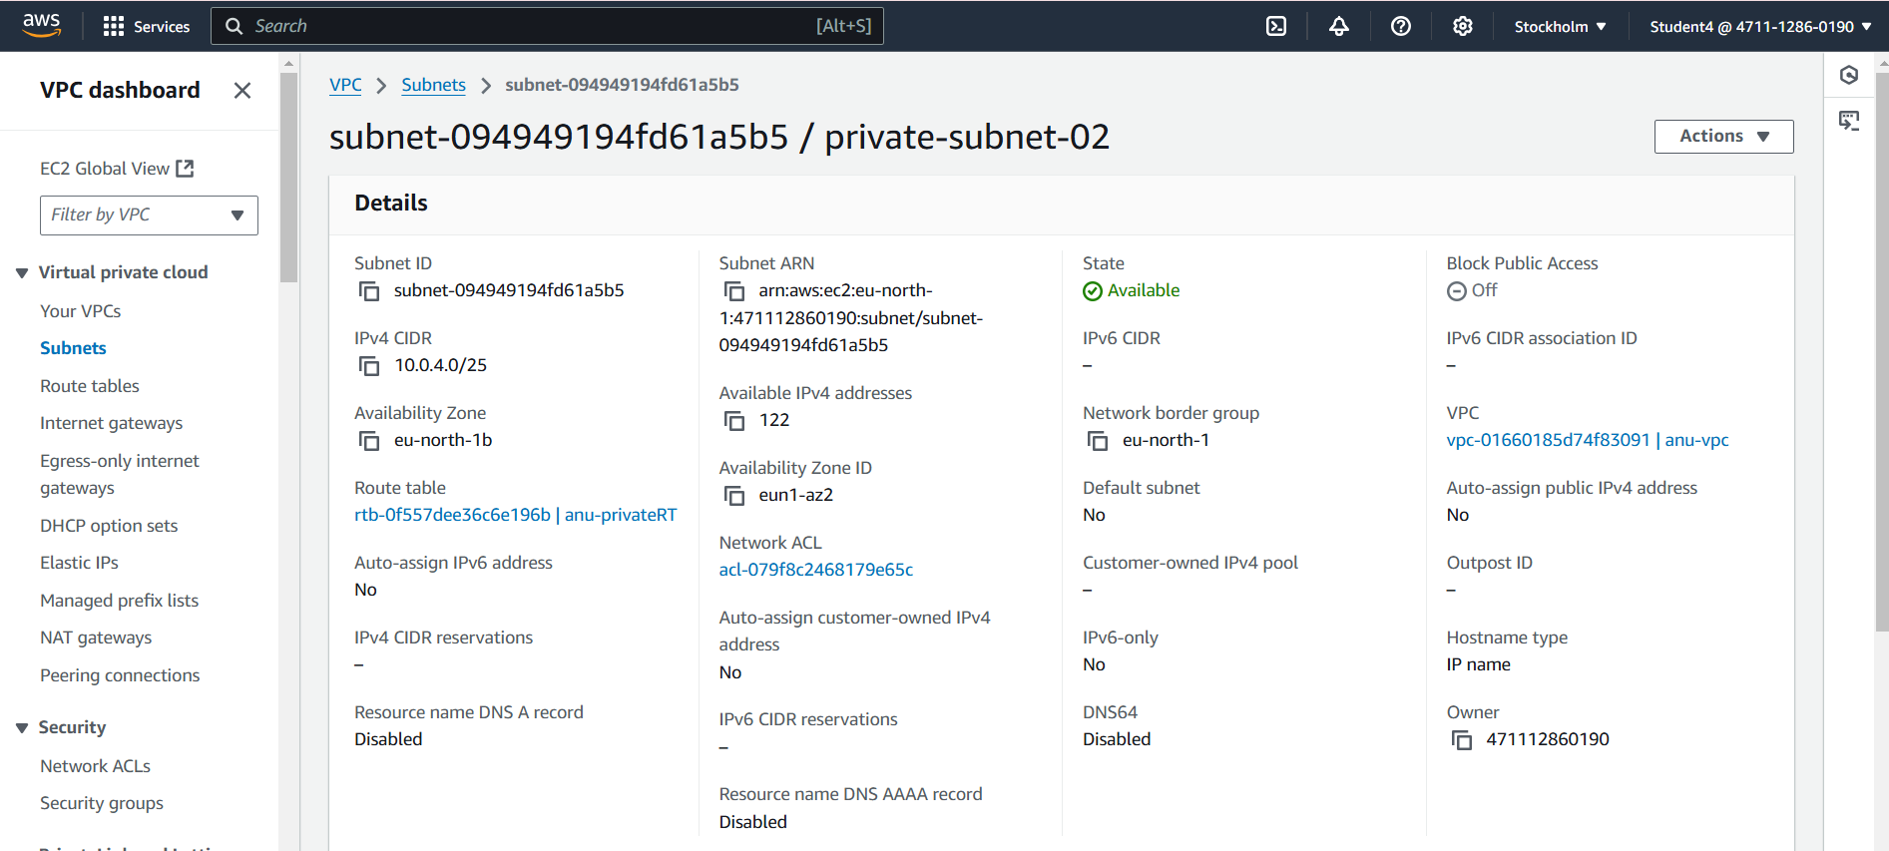

**Private route table:**

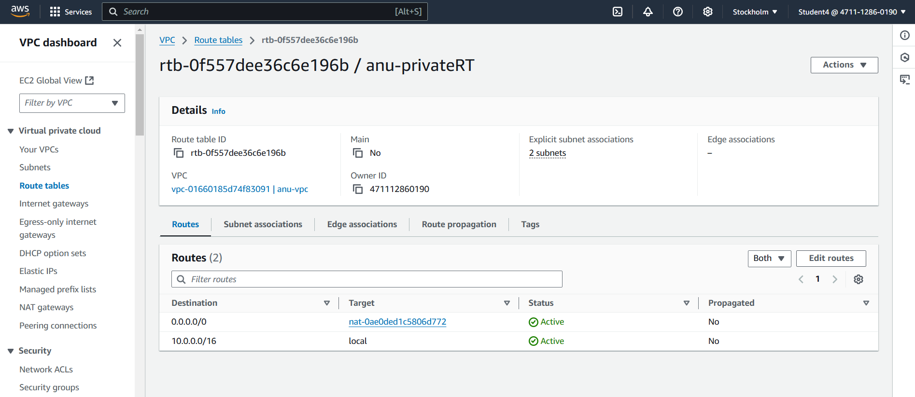

**NAT Gateway:**

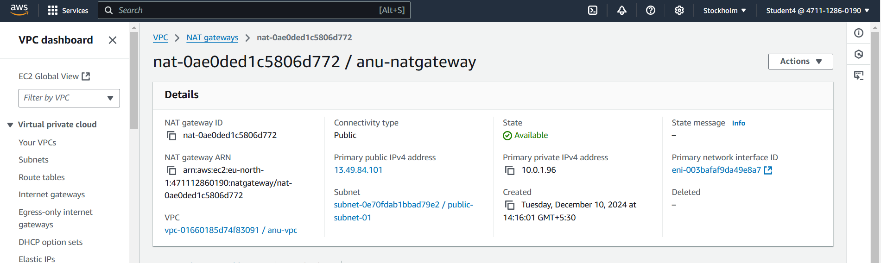

**Instances:**

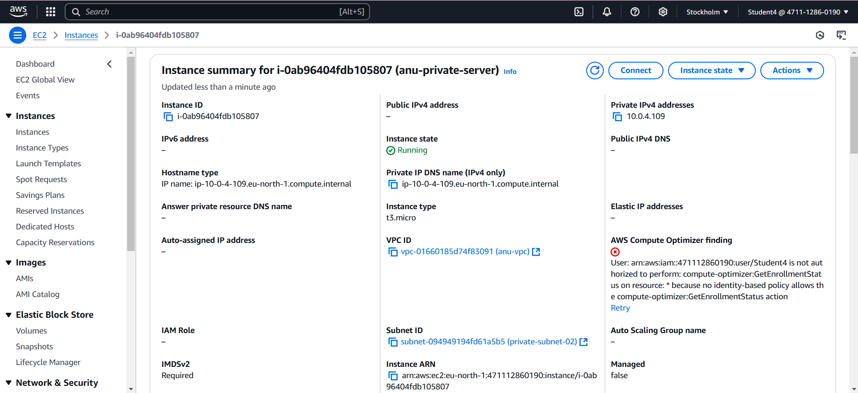

**Final result:**

